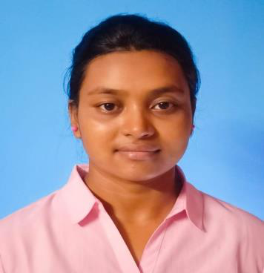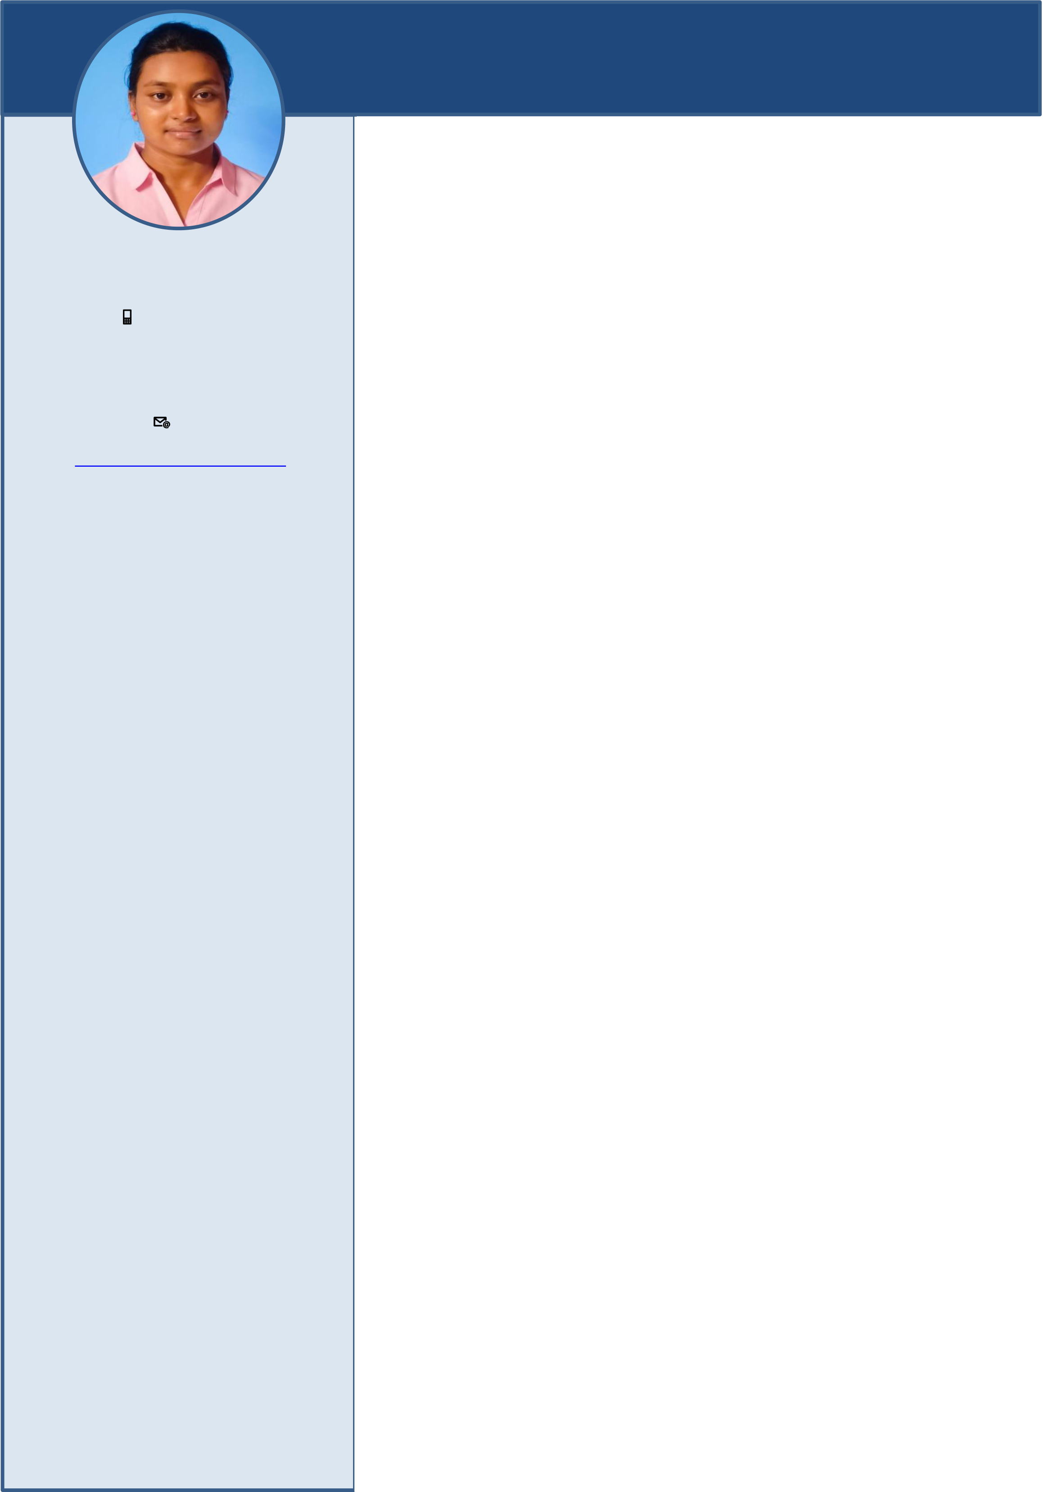

**DEBALEENA DAS**   
 **MASTER OF COMPUTER APPLICATION**

**ABOUT ME**

|  |  |
| --- | --- |
| **CONTACT**  📱**Mobile Number** 7063031416  📧**Email** | I have passed my Bachelor degree in 2021 on Computer Application .Currently I am pursuing the Master degree in Computer Application. I have good knowledge in computer Software. |

**[debaleenadas2018@gmail.com](mailto:debaleenadas2018@gmail.com)**   
 **QUALIFICATION**

**Address**

|  |  |
| --- | --- |
| Vill-Bhabanipur,P.O.-Debhog, P.S.-Bhabanipur, Haldia  721657 | ➢ **Master Of Computer Application**  Haldia Institute of Technology 2021-2023(present) |

**SKILL**

|  |  |  |
| --- | --- | --- |
| ▪ | C | ➢ **Bachelor of Computer Application** |
| ▪ | C++ | Global Institute of Technology |
| ▪ | Python | 2018-2021 |
| ▪ | PHP |
| DGPA – 8.50 |

**PROFILE**

|  |  |
| --- | --- |
| **Father’s Name**  Mr. Narayan Chandra Das  **Date of Birth**  11.09.1999 | ➢ **Higher Secondary**  Debhog Shyamacharan Milan Vidyapith 2018  Science |

Percentage – 64.2% **Nationality**

|  |  |
| --- | --- |
| Indian  **Religion**  Hindu | ➢ **Secondary**   Haldia Government Sponsored Vivekananda |

VidyaBhawan

|  |  |
| --- | --- |
| **Language known**  English, Bengali, Hindi | 2016  Percentage – 62.71% |

**Interests**

|  |  |  |
| --- | --- | --- |
| Football  Travelling | **PERSONAL PROJECT** | |
| ▪ | Email Varification Using Python. |
| ▪ | Tic Tac Toe Game using Python. |